CURRICULUMVITAE

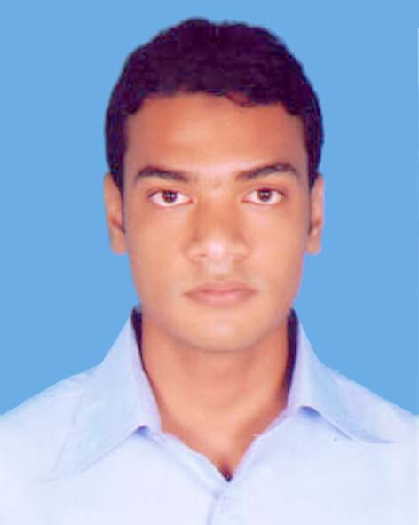

**G.M. Nahidul Hasan**

**Contact Address:**

C/O: Hashem Nibash

House No -83/C

Hill Side R/A

Chandmari Road, Lalkhan Bazar

Khulshi, Chittagong

Mobile: 01918629006

**E-mail: g.m.nahidulhasan@gmail.com**

**Career Objective:**

To face challenges using knowledge, perception and innovation to pursue long-term successful career in dynamic and professional environment of any reputable organization through my aptitude, hard work, dedication and determination.

**Academic Credentials:**

***Master of Science (M.Sc.):***

* University : National University
* Discipline : Accounting
* Year of Passing : 2011
* Result : Appeared

***Bachelor of Science (B.Sc.):***

* University : National University
* Discipline : Accounting
* Year of Passing : 2010
* Result : 2nd Class

***Higher Secondary Certificate:***

* Board : Comilla
* Group : Business Studies
* Year of Passing : 2006
* Result : GPA 3.50

***Secondary School Certificate:***

* Board : Comilla
* Group : Business Studies
* Year of Passing : 2004
* Result : GPA 3.31

**Computer Skills:**

* Have good knowledge in Microsoft Word, Excel and PowerPoint.
* Have good knowledge of using Internet & e-mail.
* Operating System: Windows 7, Windows vista, Windows XP, Windows 2000.

**Language Efficiency:**

* Good Reading, writing and oral communication ability in English.
* Very good command over Bengali (Mother Language).

**Personal Details:**

* Father’s Name : A. Matin
* Mother’s name : Nasima Akhter
* Date of Birth : 10/02/1989
* Sex : Male
* Marital Status : Single
* Nationality : Bangladeshi by birth
* Religion : Muslim
* Height : 5’-7’’
* Blood Group : A+
* Permanent address : C/O: Boro Bari

Vill: Noannai, Post: Bander hat

P.S: Sadar, Dist: Noakhali

I hereby declare that the information given above is correct to the best of my knowledge.

**…………………………**

G.M. Nahidul Hasan

Date: